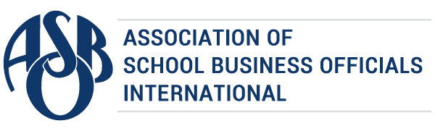

The Certificate of Excellence in Financial Reporting
is presented to

The School District of Osceola County

for its Annual Comprehensive Financial Report
for the Fiscal Year Ended June 30, 2022.
The district report meets the criteria established for
ASBO International’s Certificate of Excellence in Financial Reporting.
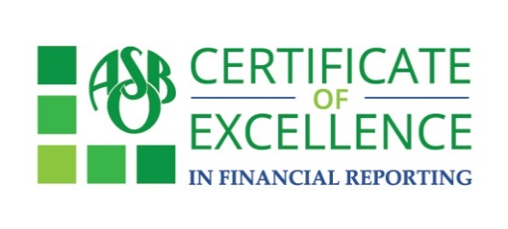

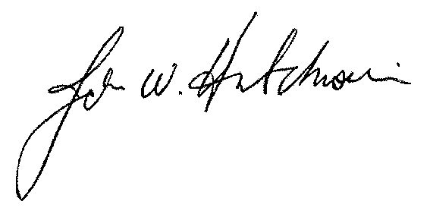

John W. Hutchison Siobhán McMahon, CAE
President Chief Operations Officer/
Interim Executive Director

March 8, 2023

Mrs. Angela Barner
Director of Finance
The School District of Osceola County
817 Bill Beck Boulevard
Kissimmee, FL 34744

Dear Mrs. Barner,

Congratulations! On behalf of the Association of School Business Officials (ASBO) International, I am pleased to inform you that The School District of Osceola County has received ASBO’s Certificate of Excellence in Financial Reporting for the fiscal year ended 2022. This award represents a significant achievement and reflects your commitment to transparency and high-quality financial reporting. We encourage you to use the COE recipient’s logo to share your achievement in emails and marketing materials.

The Certificate of Excellence (COE) Review Team has provided their comments for the improvement of your Annual Comprehensive Financial Report. It is important to review the comments and address them before you prepare next year’s report. Your district must include a copy of the original comments and the district’s written responses to the comments in next year’s application packet.

We hope you will use the attached press release to share this important achievement with
your community. Your award certificate is also attached.

Congratulations to you and the members of your staff who worked so hard to earn the COE this year. We look forward to your continued participation in the COE program.

Sincerely,
Siobhán McMahon, CAE
Chief Operations Officer/Interim Executive Director

FOR IMMEDIATE RELEASE
Contact: Susan Lambert
slambert@asbointl.org

School District Awarded for Outstanding Financial Reporting

Ashburn, VA – 2023 – The Association of School Business Officials International (ASBO) is pleased to award The School District of Osceola County the Certificate of Excellence in Financial Reporting (COE). ASBO International’s COE recognizes districts that have met the program’s high standards for financial reporting and transparency. The school district earned the Certificate of Excellence for its Annual Comprehensive Financial Report (ACFR) for the fiscal year ended 2022.

“The COE’s mission is to promote and recognize excellence in financial reporting,” ASBO International Chief Operations Officer/Interim Executive Director Siobhan McMahon says. “The Annual Comprehensive Financial Report informs stakeholders about the financial and economic state of the district, making it an important communications tool for building trust and engaging with the school community.”

By participating in the COE program, school districts demonstrate their commitment to financial transparency. Applicants submit their ACFR for review by a team of financial professionals who provide feedback to improve future documents. If the report meets the requirements of the program, it may receive the Certificate of Excellence. A district’s participation in the COE program can facilitate bond rating and continuing bond disclosure processes.

The COE is proudly sponsored by ASBO International Strategic Partner American Fidelity.

# # #

About ASBO International
Founded in 1910, the Association of School Business Officials International (ASBO) is a nonprofit organization that, through its members and affiliates, represents approximately 30,000 school business professionals worldwide. ASBO International is committed to providing programs, services, and a global network that promote the highest standards in school business. Its members support student achievement through effective resource management in various areas ranging from finance and operations to food services and transportation. Learn more at asbointl.org.

About American Fidelity
American Fidelity provides employer cost-savings solutions and supplemental insurance benefits to specific industries. Acting as an extension of the HR department, we educate, enroll, and support the development of robust, competitive insurance packages—all while ensuring seamless administration and employee satisfaction. As experts in employer benefit solutions, our salaried account managers deliver year-round support, help employers overcome benefit administrative challenges, and always offer a different perspective – a different opinion.

